**LAB QUIZ**

**PES1UG20CS150**

**GAURAV MAHAJAN**

**SET No 1:**

**1: List in descending order the number of requests sent by hospitals from the locality 'Jayanagar'.**

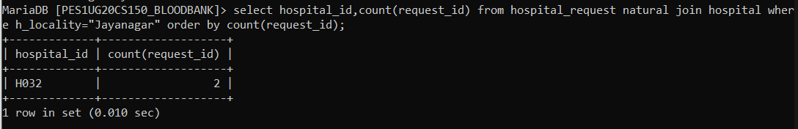

**2: Write a query to display the number of donors and the number of request for particular blood groups in the ascending order of requests**

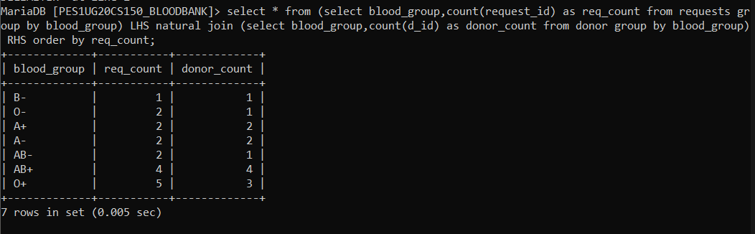

**3: Write a trigger to prevent the insertion of a donor belonging to the locality “Banashankari”.**

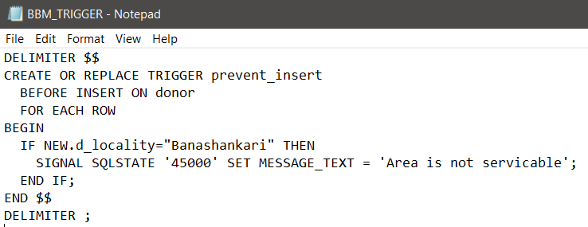

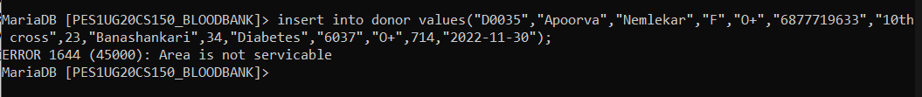

**4: Write a function to set the health status of a donor. If the donor has some associated disease set health status to “Fair”, otherwise to “Good”**

